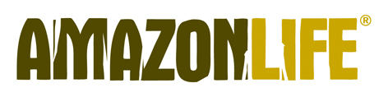
Amazonlife aims to safeguard the biodiversity of the territory which hosts about a third of tropical forests around the world and from which many of the raw materials used, such as rubber, come. The result of the work and patience of the Indians and seringueiros, the production of rubber represents an economic alternative for local people who move to the heart of the Amazon rainforest for 6 months a year, dedicating themselves to the extraction and processing of this material. AmazonLife thus contributes to the diffusion of their culture and tradition as well as to environmental protection.
The seringueiro - whose name derives from "seringueira", the rubber plant - extracts natural latex directly from the trunk, making small cuts on the bark. At least they are needed two years before it can be done a new cut. The rubber, once extracted, filtered and purified, it is spread and "spread" on a cotton canvas organic and subjected to a vulcanization process and drying in the open air and in the sun. For the production of a couple of plates, the seringueiro must draw on matter first from at least ten rubber trees. After an eight day trip on big trucks, the plates come in Rio de Janeiro to continue towards Italy
Here our style and craftsmanship merge with the colors and natural riches of Brazil, giving life to a collection of bags and t-shirts "without borders": each bag is lined with scarves, shirts or disused fabrics. Wools, cottons and prints they are ecological or recycled. All accessories are strictly nickel free.
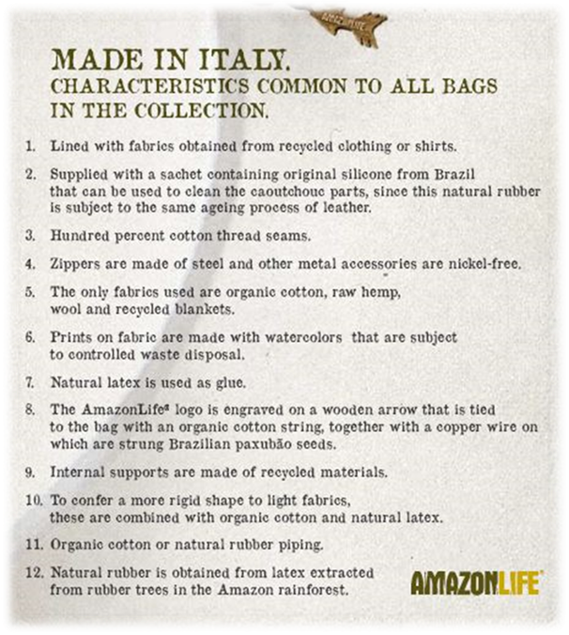

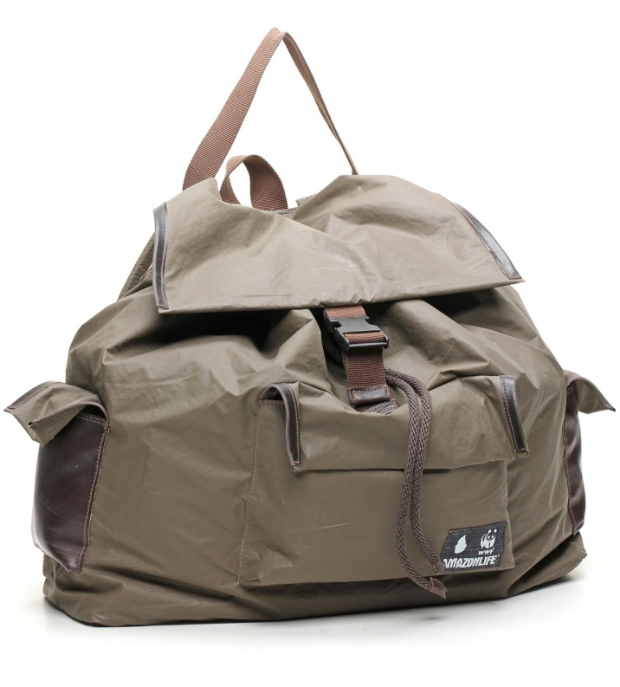
BACKPACK Poncho – AL0711
Made of rubberized ponchos of the Italian army and finished in rubber

